December 3, 2023
First Sunday of Advent


Lutheran Church of the Good Shepherd
383 Old North Rd.
Kingston, RI 02881
Email: lcgsmail2@gmail.com office: 789-7776
Rev. Dennis Kohl, Pastor
Heather Skidds, Minister of Music

Welcome to Our Visitors
In our busy world, we thank God for many things, especially your presence here. We consider it a blessing to have you among us as we gather together as people of God!
We love having guests (and celebrating your return as friends) and want to make sure you always feel welcomed. If you’re part of another community, we look forward to hearing all about it, and we look forward to welcoming you back when you can visit again!
Sunday is a time to unplug from our busy, distracted lives, and turn back to our God. Our worship service offers God’s gifts of Liturgy (the order of worship), God’s Word (through Scripture and Sermon), Prayer, and the Sacrament of Holy Communion.
We are a “Reconciling in Christ” church of the ELCA. It means that we affirm + accept all people regardless of age, race, ethnicity, legal status, economic situation, sexual orientation, gender identity, marital status, physical or emotional conditions, and whatever else we didn’t list here. We believe that God creates us ALL in the image of God, and loves us unconditionally, and helps us to do the same with everyone. We also believe God desires that everyone should have the opportunity to participate in the life and worship of a faith community. We’re glad you’re here!

Assistants for today- Assisting Minister- Marie Bender Lee
Lector- David Nunez
Greeter/Usher- Riitta Passananti
Communion Assistant- Deb Crary
Altar Care- Fred Baillargeron/Kathy Vigness Raposa

Assistants for Dec 10 2023- Assisting Minister- Karen Amitrano
Lector- Fred Baillargeron
Greeter/Usher- Naomi & Fred Sawyer
Communion Assistant- Arlene Anderson
Altar Care- Ann Lessmann

+Gathering+
Prelude- Andante Cantabile, Johann Christian Bach

Stand

Confession and Forgiveness
All may make the sign of the cross, the sign that is marked at baptism, as the presiding minister begins.
Blessed be the holy Trinity, ☩ one God,
who opens the heavens
and draws near to us with salvation. Amen.
God is patient and merciful, desiring all to come to repentance.
Trusting this promise of grace, let us confess our sin.
Silence is kept for reflection.
Everlasting God,
you love justice and you hate wrongdoing.
We confess the fear, greed, and self-centeredness
that make us reluctant to work against oppression.
We are complicit in systems of exploitation.
We choose comfort over courage.
We are careless with creation’s bounty.
Look upon us with mercy.
Turn our hearts again to you.
Make us glad to do your will and to walk in your ways
for the sake of our waiting world. Amen.
Hear these words of assurance:
God clothes you with garments of salvation
and covers you with robes of righteousness.
In the tender compassion of ☩ Jesus Christ,
your sins are forgiven.
God’s covenant is eternal,
and God’s blessing rests upon us all. Amen.

Gathering Hymn- ELW 257O Come, O Come Emanuel, vs. 1-4

Greeting
The grace of our Lord Jesus Christ, the love of God, and the fellowship of
the Holy Spirit be with you all. And also with you.

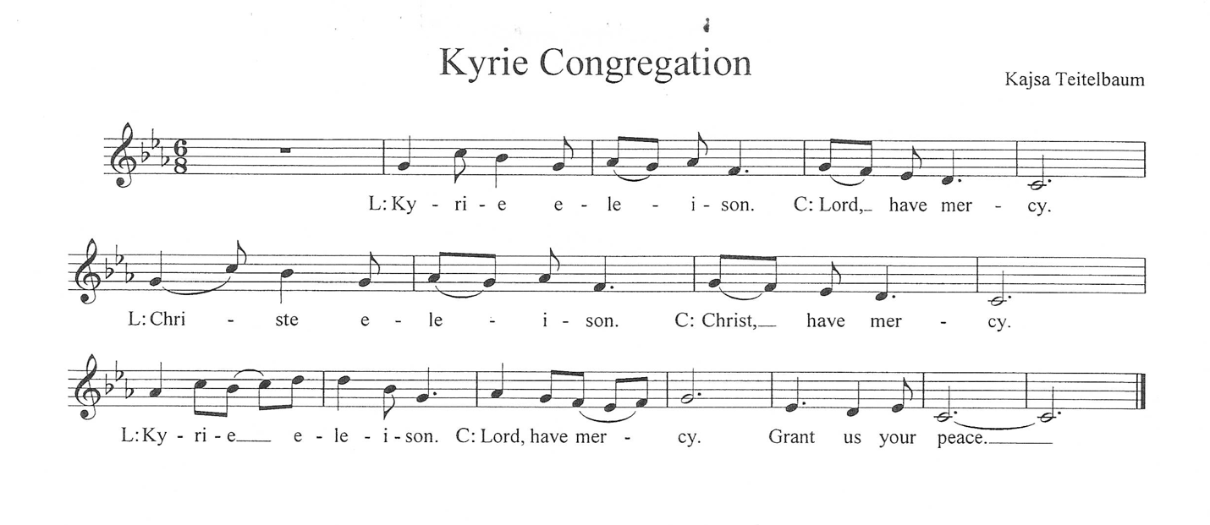
The Lord be with you. And also with you.
Prayer of the Day- Let us pray. (Brief silence)
Stir up your power, Lord Christ, and come. By your merciful protection awaken us to the threatening dangers of our sins, and keep us blameless until the coming of your new day, for you live and reign with the Father and the Holy Spirit, one God, now and forever. Amen.

ELW 253 He Came Down vs.1
Lighting the Advent wreath
Praise to you, O God, our salvation who is near. You hold us in our waiting and keep us awake to the world. You show up in our lives at unexpected times.
Bless us as we light this candle to keep vigil for your arrival. We trust that even though we do not know the day or the hour, you hurry to gather all people to your peace. Amen.

Sit

First Reading: Isaiah 64:1-9
¹O that you would tear open the heavens and come down,
so that the mountains would quake at your presence—
²as when fire kindles brushwood
and the fire causes water to boil—
to make your name known to your adversaries,
so that the nations might tremble at your presence!
³When you did awesome deeds that we did not expect,
you came down, the mountains quaked at your presence.
⁴From ages past no one has heard,
no ear has perceived,
no eye has seen any God besides you,
who works for those who wait for him.
⁵You meet those who gladly do right,
those who remember you in your ways.
But you were angry, and we sinned;
because you hid yourself we transgressed.
⁶We have all become like one who is unclean,
and all our righteous deeds are like a filthy cloth.
We all fade like a leaf,
and our iniquities, like the wind, take us away.
⁷There is no one who calls on your name,
or attempts to take hold of you;
for you have hidden your face from us,
and have delivered us into the hand of our iniquity.
⁸Yet, O Lord, you are our Father;
we are the clay, and you are our potter;
we are all the work of your hand.
⁹Do not be exceedingly angry, O Lord,
and do not remember iniquity forever.
Now consider, we are all your people. Word of God, Word of Life. Thanks be to God.

Psalm: Psalm 80:1-7, 17-19 prayed responsively
¹Hear, O Shepherd of Israel, leading Joseph like a flock;
shine forth, you that are enthroned upon the cherubim.
²In the presence of Ephraim, Benjamin, and Manasseh,
stir up your strength and come to help us.
³Restore us, O God;
let your face shine upon us, and we shall be saved.
⁴O Lord God of hosts,
how long will your anger fume when your people pray?
⁵You have fed them with the bread of tears;
you have given them bowls of tears to drink.
⁶You have made us the derision of our neighbors,
and our enemies laugh us to scorn.
⁷Restore us, O God of hosts;
let your face shine upon us, and we shall be saved.
¹⁷Let your hand be upon the one at your right hand,
the one you have made so strong for yourself. R
¹⁸And so will we never turn away from you;
give us life, that we may call upon your name.
¹⁹Restore us, O Lord God of hosts;
let your face shine upon us, and we shall be saved. Amen

Second Reading: 1 Corinthians 1:3-9
³Grace to you and peace from God our Father and the Lord Jesus Christ.
⁴I give thanks to my God always for you because of the grace of God that has been given you in Christ Jesus, ⁵for in every way you have been enriched in him, in speech and knowledge of every kind—⁶just as the testimony of Christ has been strengthened among you—⁷so that you are not lacking in any spiritual gift as you wait for the revealing of our Lord Jesus Christ. ⁸He will also strengthen you to the end, so that you may be blameless on the day of our Lord Jesus Christ. ⁹God is faithful; by him you were called into the fellowship of his Son, Jesus Christ our Lord. Word of God, Word of Life. Thanks be to God.

Stand
Gospel Acclamation K. Teitelbaum
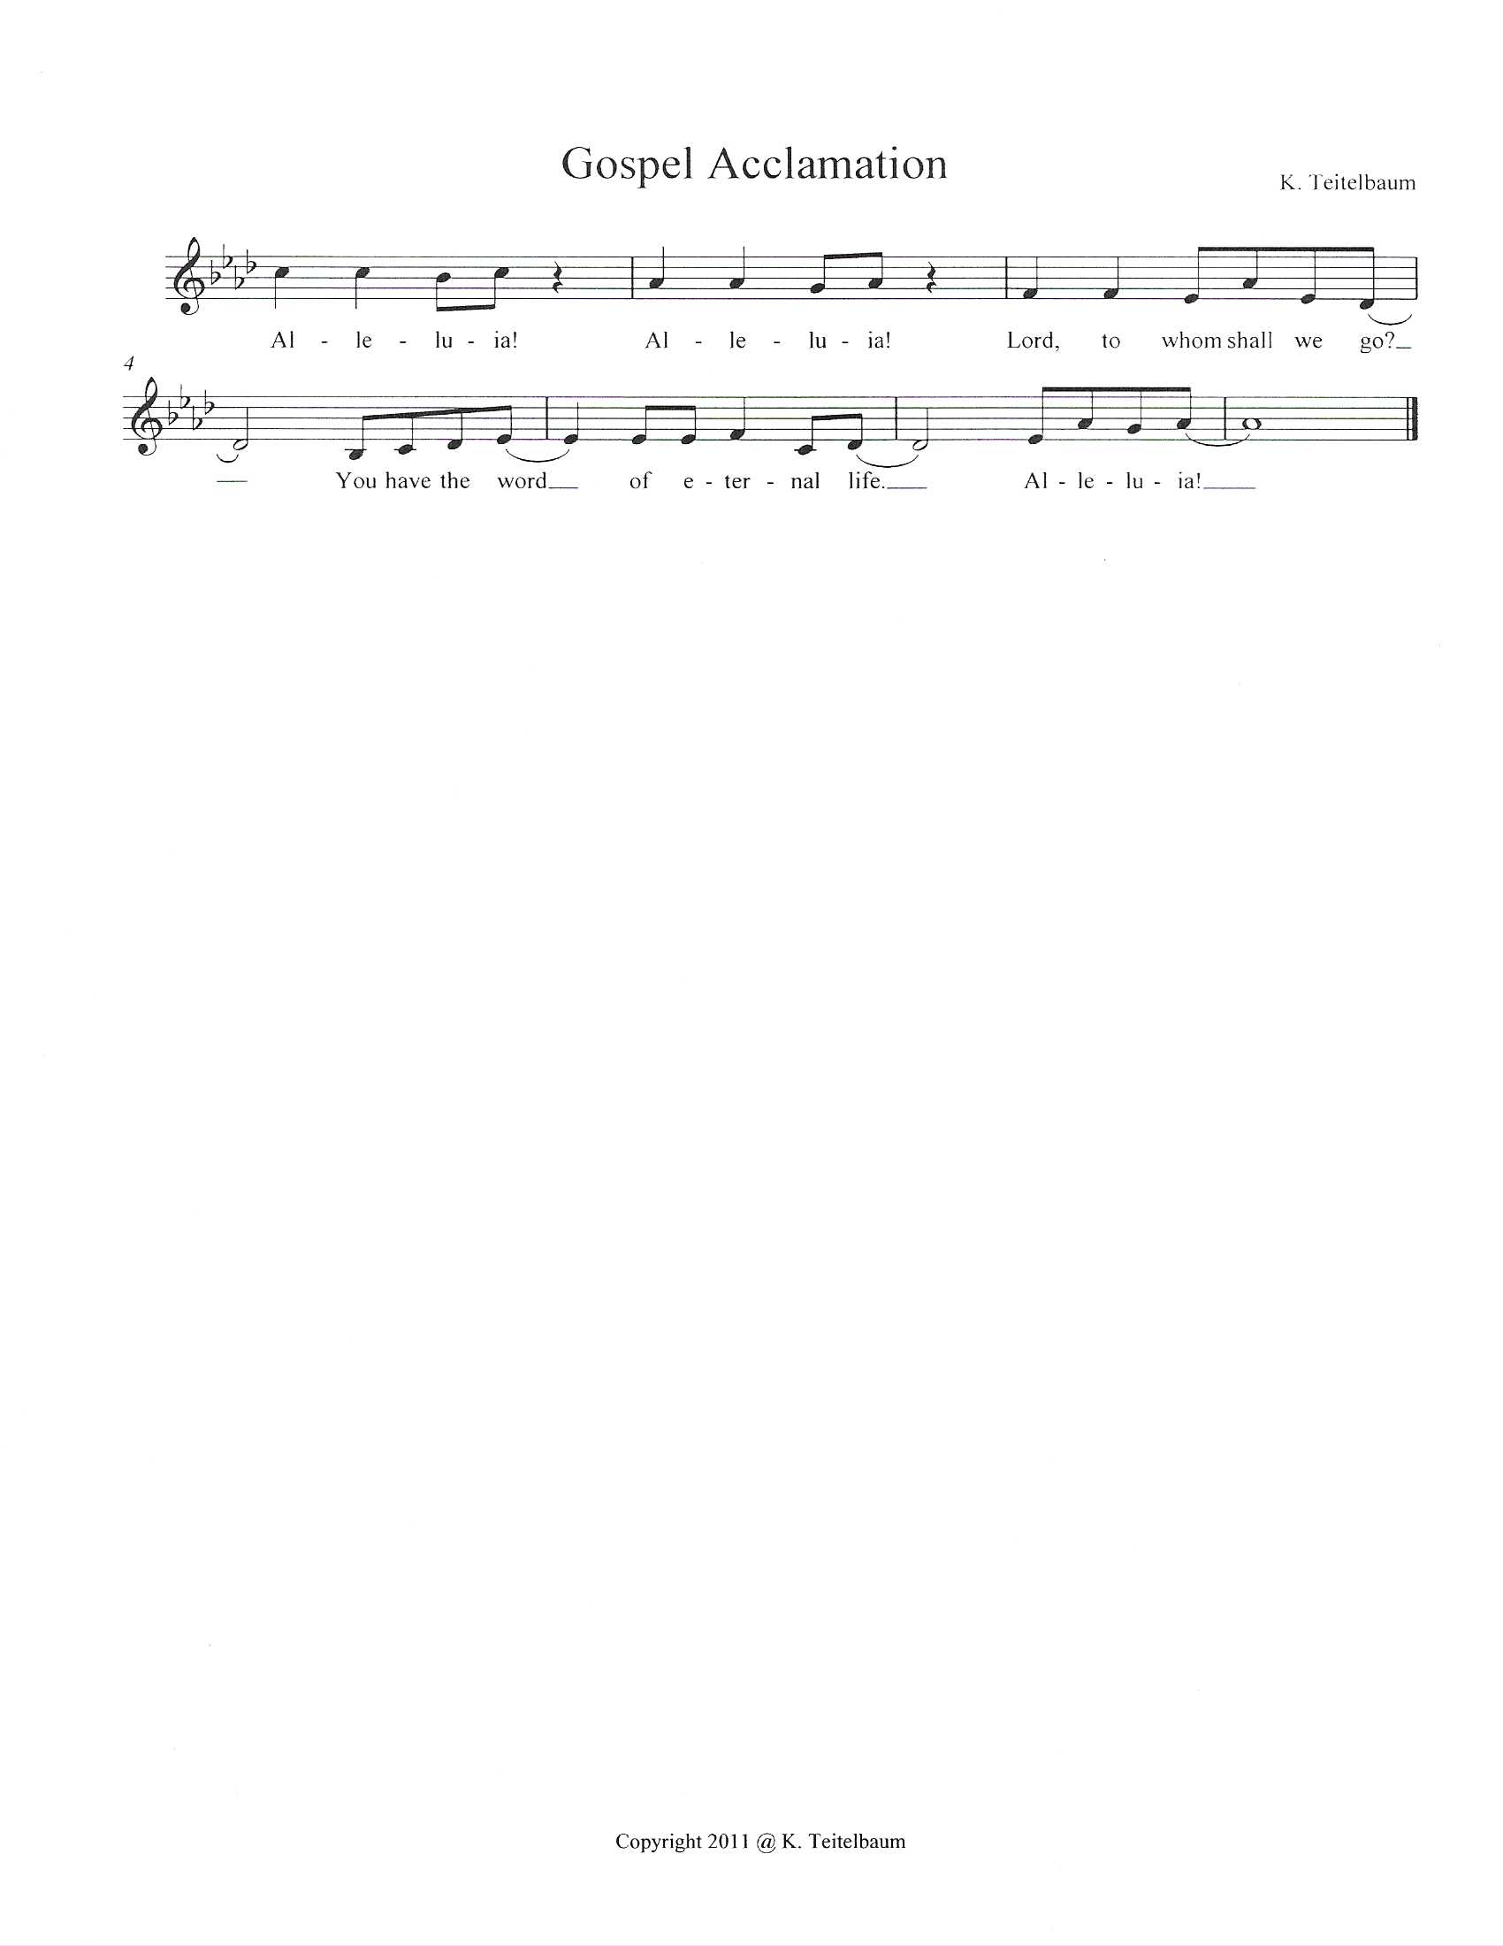

Gospel: Mark 13:24-37
The Holy Gospel according to Mark.
Glory to you, O Lord.

[Jesus said:] ²⁴“In those days, after that suffering,
the sun will be darkened,
and the moon will not give its light,
²⁵and the stars will be falling from heaven,
and the powers in the heavens will be shaken.
²⁶Then they will see ‘the Son of Man coming in clouds’ with great power and glory. ²⁷Then he will send out the angels, and gather his elect from the four winds, from the ends of the earth to the ends of heaven.
²⁸“From the fig tree learn its lesson: as soon as its branch becomes tender and puts forth its leaves, you know that summer is near. ²⁹So also, when you see these things taking place, you know that he is near, at the very gates. ³⁰Truly I tell you, this generation will not pass away until all these things have taken place. ³¹Heaven and earth will pass away, but my words will not pass away.
³²“But about that day or hour no one knows, neither the angels in heaven, nor the Son, but only the Father. ³³Beware, keep alert; for you do not know when the time will come. ³⁴It is like a man going on a journey, when he leaves home and puts his slaves in charge, each with his work, and commands the doorkeeper to be on the watch. ³⁵Therefore, keep awake—for you do not know when the master of the house will come, in the evening, or at midnight, or at cockcrow, or at dawn, ³⁶or else he may find you asleep when he comes suddenly. ³⁷And what I say to you I say to all: Keep awake.”
The Gospel of our Lord.
Praise to you, O Christ.
Sit

SERMON

Stand
HYMN OF THE DAY ELW 244 Rejoice, Rejoice Believers

Nicene Creed
Baptized into Christ, with the whole Church, let us confess our faith.
We believe in one God,
the Father, the Almighty,
maker of heaven and earth,
of all that is, seen and unseen.
We believe in one Lord, Jesus Christ,
the only Son of God,
eternally begotten of the Father,
God from God, Light from Light,
true God from true God,
begotten, not made,
of one Being with the Father;
through him all things were made.
For us and for our salvation
he came down from heaven,
was incarnate of the Holy Spirit and the virgin Mary
and became truly human.
For our sake he was crucified under Pontius Pilate;
he suffered death and was buried.
On the third day he rose again
in accordance with the scriptures;
he ascended into heaven
and is seated at the right hand of the Father.
He will come again in glory to judge the living and the dead,
and his kingdom will have no end.
We believe in the Holy Spirit, the Lord, the giver of life,
who proceeds from the Father and the Son,
who with the Father and the Son is worshiped and glorified,
who has spoken through the prophets.
We believe in one holy catholic and apostolic church.
We acknowledge one baptism for the forgiveness of sins.
We look for the resurrection of the dead,
and the life of the world to come. Amen.

PRAYERS OF INTERCESSION
A.M: Merciful God, receive our prayer.
PR: Listen to these and all our prayers, O God of hosts, and restore us with your great and everlasting mercy.
Amen.

PEACE
The peace of Christ be with you always.
And also with you.
People share a sign of peace and reconciliation with one another.
Sit
Choir Anthem- Chose to Hope
Stand
PRESENTATION OF THE CONGREGATION’S OFFERINGS

OFFERING PRAYER
Let us pray.
AM: God our provider,
by your merciful hand abundance springs up from the earth.
Receive and bless these gifts of your own bounty. Let them be a sign of your steadfast love and faithfulness for all people, through Jesus Christ our Savior. Amen.
+MEAL+
GREAT THANKSGIVING
The Lord be with you. And also with you.
Lift up your hearts. We lift them to the Lord.
Let us give thanks to the Lord our God.
It is right to give God thanks and praise.

It is indeed right, our duty and our joy, That we should at all times and in all places give thanks and praise to you, Almighty and merciful God, through our Savior Jesus Christ. You comforted your people with the promise of the Redeemer, through whom you will make all things new in the day when he comes to judge the world in righteousness. And so, with all the choirs of angels,
With the church on earth end the hosts of heaven, we praise your name and join their unending hymn
Sanctus K. Teitelbaum

Thanksgiving at the Table
The pastor and people pray the Thanksgiving at the Table
Holy One, the beginning and the end…
Let us proclaim the mystery of faith;
Christ has died. Christ has risen. Christ will come again.
With this bread and cup…we look with hope for his coming again.
Come, Lord Jesus.
Holy God…Bring your gift of peace on earth.
Come, Holy Spirit.
All praise and glory…one God, now and forever. Amen.
Gathered into one by your Holy Spirit, let us pray as Jesus taught us.
Our Father…

Distribution of Holy Communion
Our congregation practices eucharistic hospitality. We believe that the resurrected Christ is truly present in the bread and wine with his gifts of life, forgiveness of sin, and salvation. All the baptized are welcome at the Lord’s table. Please gather around the altar to receive the bread and wine, if you are wearing a mask, remove it to eat and drink the sacrament. Both wine and non-alcoholic wine is available in the small cups. The chalice containing wine for those who wish to use intinction (dipping the bread into the wine). The small cups may be placed in the baskets on either side of the altar area as you return to your seat by the side aisles.
Invitation to the table
In this meal, righteousness and peace meet together. Come, take your place at the table.

Please remain standing
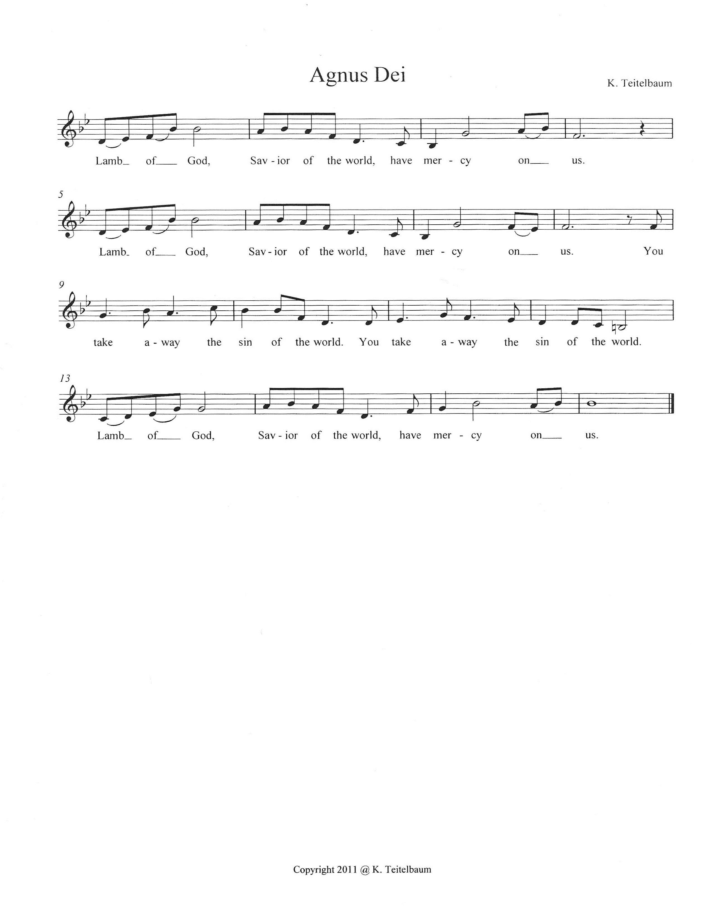
Sit
Communion Reflection- ELW 245 Creator of the Stars of Night (sing along if you wish)
When all have communed, please STAND as you are able.

BLESSING
The body and blood of our Lord Jesus Christ strengthen you and keep you
in his grace. Amen.
SENDING+
Prayer After Communion AM: Generous God, in bread and cup you have revealed your glory for all people to see together. Nourished by this meal, send us out to proclaim your good news of liberation and release, brought to birth in Jesus Christ our Savior. Amen.
BENEDICTION
The Lord bless you and keep you.
The Lord’s face shine on you with grace and mercy.
The Lord look upon you with favor and give you + peace. Amen.

ANNOUNCEMENTS
Sending Hymn- ELW 260 The King Shall Come

AM: Go in peace. Share the good news.
Thanks be to God.

POSTLUDE- Venez, Divin Messie

Sundays and Seasons v.20220215.1125
Copyright © Augsburg Fortress. All rights reserved.
Announcements
Acolyte training after worship today.

Staff Gifts- December is when we show our appreciation for our hard-working staff by collecting donations for "Staff Gifts", usually presented to them on Christmas Eve. Let’s show them how appreciated they are! Please make checks out to the church by Dec 17 and mark them "staff gift" so the counters will know what it's for.

Outreach
Here’s a quick glimpse of what’s going on with Outreach:
~There are Christmas cards, for immigrants and refugees who are in detention centers, on the table in Anderson Hall; if you are able to take a few minutes to write one or two out that would be greatly appreciated.
~There’s a bin to collect men's clothing for Mathewson Street Ministries. They are looking for NEW socks, underwear, hats and gloves. They are also collecting like-new and washed jeans, khakis, fleeces, flannel shirts and jackets.
~Gift Cards are available to purchase and donate to The Jonnycake Center, Mathewson Street Ministry, The Welcome House, and The Domestic Violence Resource Center. Please speak to Ann Senerchia to order gift cards from our Raise Right program. Thank you for your support!

Ongoing Prayers for:

For those who mourn: Our thoughts and prayers are with Nancy Mowbray and her family, on the passing of her sister Karen.

Also, we pray and think of Donna Gilton, who passed away on Tuesday. She will be missed as a member, and part of our choir for many years. Her service will held next Saturday, December 9. Details to follow!

For additions or deletions please text or call Nancy Mowbray at 401-744-
9051 or the church office.

Billy Wernquest
Ruth Wernquest
Norma McEntee
Holly Deutsch
Linda Mills
Ellen Bennett
Tina Guerin
Mary Jane Briggs
Bill Deutsch
Meredith Miller
Gary Durett
Natalie Schanck
Mike Carty
Barbara Smith
Eero Moisio
Phyllis Farley
Lane Leedahl
Brian Mitchell
Barney
Joyce Pearson
Daniel Deutsch
Amy Phillipo
Karolyn Lee
Kathy Lee
Chris Rose
Colette Cusson new
Dennis Murray
Lisa Ferry
Ellora Hendrickson
Melvin Platt
KC Christensen
Jan Briggs
Ruth McGuy
Bud Godwin
Lisa Lessman
Taylor Lessman
Joan & Sheldon Pratt
Jerry Paquin
Stanley Larson
Ellen Hedlund
Donald & Bernadine Cunnigen,
Maggie Reichgott
Tucker Maute
Karen Perry
Mark Quinn
Rob Ryan
Larrie Gray
Carolyn Hathaway
Betty Hathaway
Tim Diskin

+HOMEBOUND;SKILLED NURSING+
Bob Lindstrom Gilda Schroeder
+LOVED ONES IN THE ARMED FORCES+ Manny Morales, Michael Bock
Matthew Kankash, Heath O’Neill, Andrew Anderson, Noah Cooper,
Dan Berkowitz

